**RETURN OF INTERNATIONAL STUDENTS   
TO BOARDING SCHOOLS**

The bearer of this letter is travelling to the UK to begin or resume their education at a member school of the Boarding Schools’ Association. The school has undertaken to ensure full compliance with any Government quarantine or self-isolation requirements which are in force at the time of arrival. A school’s membership of BSA can be verified at: <https://www.boarding.org.uk/388/school-search>

STUDENT NAME _________________________________________________

DATE AND TIME OF ARRIVAL _______________________________________

FLIGHT NUMBER _________________________________________________

NAME OF SCHOOL _______________________________________________

NAME OF PERSON COLLECTING STUDENT Mrs Barbara Pring

CONTACT NUMBER OF PERSON COLLECTING 07502 434397

SCHOOL CONTACT NAME Emma Day, School Administrator

SCHOOL CONTACT NUMBER 01732 304246

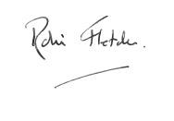

Robin Fletcher 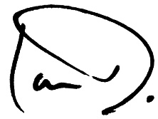  
Chief Executive ___________________  
Boarding Schools’ Association and Headteacher/ Principal  
BSA Group